**Shubham P. Kumbhar**

**Wipro Assignments**

**Software Development Life Cycle**

--------------------------------------------------------------------------------------------  **Que 1**. **SDLC for E-Commerce :**

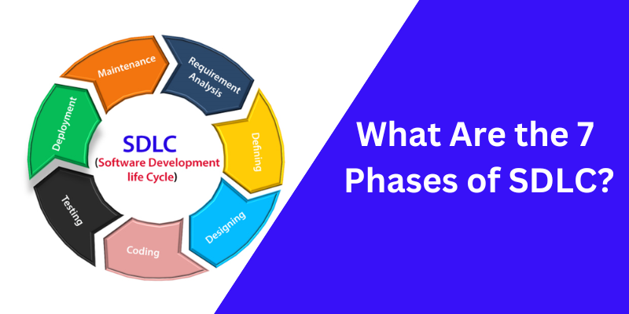

Here's a detailed breakdown of the Software Development Life Cycle (SDLC) for the eCommerce application, following the specified points:

**1. Requirement Analysis**

* **Objective**: Understand and document what the application needs to achieve.
* **Activities**:
  + **Stakeholder Meetings**: Engage with clients, users, and other stakeholders to gather their needs and expectations.
  + **Requirement Gathering**: Collect detailed requirements for features such as user login, product display, sorting, cart management, and checkout.
  + **Document Requirements**: Create comprehensive documentation including functional and non-functional requirements.
  + **Create Use Cases/User Stories**: Develop scenarios outlining how users will interact with the application.
* **Deliverables**:
  + Requirements Specification Document
  + Use Cases/User Stories
  + Requirements Traceability Matrix

**2. Defining**

* **Objective**: Plan and outline the project’s approach and resources.
* **Activities**:
  + **Project Planning**: Develop a project plan detailing the timeline, milestones, and resource allocation.
  + **Budgeting**: Estimate costs for development, testing, deployment, and maintenance.
  + **Resource Planning**: Allocate team members, technology, and other resources.
  + **Risk Management**: Identify potential risks and develop mitigation strategies.
  + **Define Deliverables**: Clearly state what will be delivered at each phase.
* **Deliverables**:
  + Project Plan
  + Budget Estimates
  + Resource Allocation Plan
  + Risk Management Plan

**3. Designing**

* **Objective**: Create detailed designs for the application’s architecture and components.
* **Activities**:
  + **High-Level Design**: Define the system architecture, including components, their interactions, and data flow.
  + **Detailed Design**:
    - **UI/UX Design**: Develop wireframes and mockups for user interfaces.
    - **Database Design**: Create the database schema, including tables, relationships, and indexes.
    - **Component Design**: Define the design for individual modules and their interactions.
    - **Security Design**: Plan for authentication, data protection, and secure transactions.
* **Deliverables**:
  + High-Level Design Document
  + Detailed Design Documents
  + UI/UX Mockups
  + Database Schema
  + Security Plan

**4. Coding**

* **Objective**: Develop the application based on the design specifications.
* **Activities**:
  + **Front-End Development**: Build user interface components such as login screens, home page, product listings, and checkout pages.
  + **Back-End Development**: Implement server-side logic including authentication, product management, and cart functionality.
  + **Database Development**: Create and configure the database with tables, procedures, and data access logic.
  + **Integration**: Ensure that front-end and back-end components work together seamlessly.
  + **Code Review**: Review code for quality and adherence to standards.
* **Deliverables**:
  + Source Code
  + Integrated Application Components
  + Database Setup Scripts

**5. Testing**

* **Objective**: Verify that the application functions as intended and is free of defects.
* **Activities**:
  + **Unit Testing**: Test individual components or units of code.
  + **Integration Testing**: Test the interactions between integrated components.
  + **System Testing**: Conduct end-to-end testing of the entire application.
  + **User Acceptance Testing (UAT)**: Validate the application with end-users to ensure it meets their needs.
  + **Bug Fixing**: Address and resolve any issues found during testing.
* **Deliverables**:
  + Test Plans
  + Test Cases
  + Test Reports
  + UAT Feedback

**6. Deployment**

* **Objective**: Release the application to the production environment.
* **Activities**:
  + **Environment Preparation**: Set up the production environment, including server configuration and data migration.
  + **Deployment**: Deploy the application to the live server.
  + **Smoke Testing**: Perform initial testing to verify that the deployment was successful.
  + **User Training**: Provide training and documentation for end-users and administrators if needed.
* **Deliverables**:
  + Live Application
  + Deployment Report
  + Training Materials

**7. Maintenance**

* **Objective**: Provide ongoing support and updates post-deployment.
* **Activities**:
  + **Monitoring**: Continuously monitor application performance and user feedback.
  + **Issue Resolution**: Address and fix bugs or issues as they arise.
  + **Updates and Enhancements**: Implement updates, patches, and new features based on feedback and changing requirements.
  + **Documentation Updates**: Keep documentation current with any changes made.
* **Deliverables**:
  + Maintenance Logs
  + Bug Fixes
  + Feature Updates
  + Updated Documentation

This detailed SDLC approach ensures each phase is carefully executed to develop and maintain a robust eCommerce application.